Alicia Spezialetti PSS LC: Financial Analyst II
1351 N. ROLFE ST. PHONE:607.742.4794
ARLINGTON, VA 22209 ASPEZIALETTI@COBEC.COM
Background
Extensive experience in analyzing sales and performance metrics, creating strategies to support growth and align payroll/store budgets, effective scheduling and maintenance of inventory allocation databases. Nine years of progressively managing and multi-tasking program management, with a career focus on Human Resources & Recruiting. Extensive experience in recruiting, hiring, training and developing a high level, self-managing team; fostering a collaborative growth environment. Fast learner, with exceptional verbal and written communication skills. Proficient in Microsoft Office Suite, E-Verify, UltiPro Systems.

Work History and Professional Accomplishments
Consultant | COBEC CONSULTING, INC  WASHINGTON, DC | Aug. 2021- Present  6 Mon.
Facilitate, manage, and educate two Agile teams in SAFe (Scaled Agile Framework) Methodology as a Certified Scrum Master as part of the Configuration, Logistics, and Maintenance Resource Solutions (CLMRS) portfolio. Facilitate daily team and system meetings including a Community of Practice to create effective relationships within the System Team. Analyze sprint capacity versus actual workload and completion rates, assisting the team in establishing normalized work estimates. Identify and remove impediments relating to the team’s workflow and foster an environment for high- performing team dynamics, continuous flow and improvement. Collaborate with and support Product Owners for each team in clearly defining project’s goals, scope, and maintenance of the product backlog. Extensive experience in Jira/Confluence workflow management tool. Liaise with other Scrum Masters and stakeholders to improve overall program effectiveness.

Consultant | COBEC CONSULTING, INC  WASHINGTON, DC | Aug. 2020 – Aug. 2021  1 Year

Analyze and migrate logistical data from various sources in current FAA systems to a new database system retained by an Enterprise Resource Planning (ERP) tool at the FAA, IFS. Supporting the implementation of Configuration Management Automation (CMA) as part of the Configuration, Logistics, and Maintenance Resource Solutions (CLMRS) portfolio. Liaise with various members of the NAS Configuration Control Board (CCB) in addition to second level engineering, system owners and managers from all NAS System CCBs in support of coordination of data exchange between parties, communication of completeness and if data population is meeting intended requirements. Familiar with SAFe Lean Agile business implementation and delivery.

Store Manager | PANDORA, LLC  WASHINGTON, DC | May 2017- July 2020  3 Yrs. 2 Mos

Analyze and drive key sales and performance metrics through KWI reporting, provide insight and strategies on business markets to grow company initiatives. Working independently to develop goal attainment plans for associate and leadership teams in various divisions i.e. operational efficiency (sales strategy and forecasting, analyzing/ rectifying P&L statements, daily analysis of payroll budgets for district via Excel), inventory analysis (including product ordering/ maintenance of product allocation databases, and rectification of variances). Effective scheduling; aligning payroll budgets, referencing sales, product allocation, and foot-traffic reporting based on previous year’s trends. Under my leadership, I have promoted two assistant mangers and on-boarded three Store Managers for the district. I was promoted in January 2020 to manage a higher volume location based on positive contribution and performance.

Store Manager | CLUB MONACO  MCLEAN, VA | July 2016-January 2017  5 Mos
Analyzed business results daily, utilizing company reports and various KPI metrics, executing merchandising directives. Managed daily operational/ facilities procedures including payroll processing/management and effective staff scheduling. Primary human resources liaison managing all functions including recruiting, interviewing, hiring (to include background checks, I-9 processing, E-Verify) on-boarding, training and development thereafter. Identified strategic goal attainment action plans for leadership team.

Store Manager | ANTHROPOLOGIE FAIRFAX,VA | April, 2013-July 2016  3 Yrs, 3 Mos
Responsible for leading and developing a team of 30+ stylists, department and supervisor level managers at a 3M dollar door. Managed all operational procedures including effective sales analysis and forecasting, scheduling based on previous years trends, payroll budgeting and management. Strategically identified developmental strengths and opportunities of management team, conducted monthly one on ones to ensure goal attainment in identified opportunistic areas. Managed full hiring process including recruiting, interviewing, on-boarding, and all human resources processes thereafter including bi-annual evaluations of staff and managing/guiding the self-assessment process. I received a promotion to a larger volume store based on positive contribution and performance.
Operations Manager | J. CREW RESTON, VA | Aug. 2011- Apr. 2013  1 Yr. 8 Mos

Analyzing sales results and scheduled to maximize payroll efficiency. Assisted in recruiting and hiring process, including pre-screening, interviewing candidates; onboarding, training post-hire.

Marketing Assistant | GUTHRIE HEALTHCARE SYSTEM  SAYRE, PA | June 2009- June 2011  1 Yr.
Managed office procedures for planning, marketing, website, and public relations functions. Developed formal presentations, scheduled meetings, maintained comprehensive invoice databases, and facilitated bulk mailings. Planned and managed all logistics and executed various functions for events including Women and Heart Disease Event, Cancer Center Campaign launch, and three regional Women’s Advisory Groups. Provided high-level administrative/marketing support for Senior Vice President of Strategic Planning and Implementation.

Education
B.A., Communications/ Public Relations | University of Scranton, Scranton, PA | May 2009
Professional Certifications
SAFe Agile Scrum Master Certification | Scaled Agile, provider of SAFe | August 2021

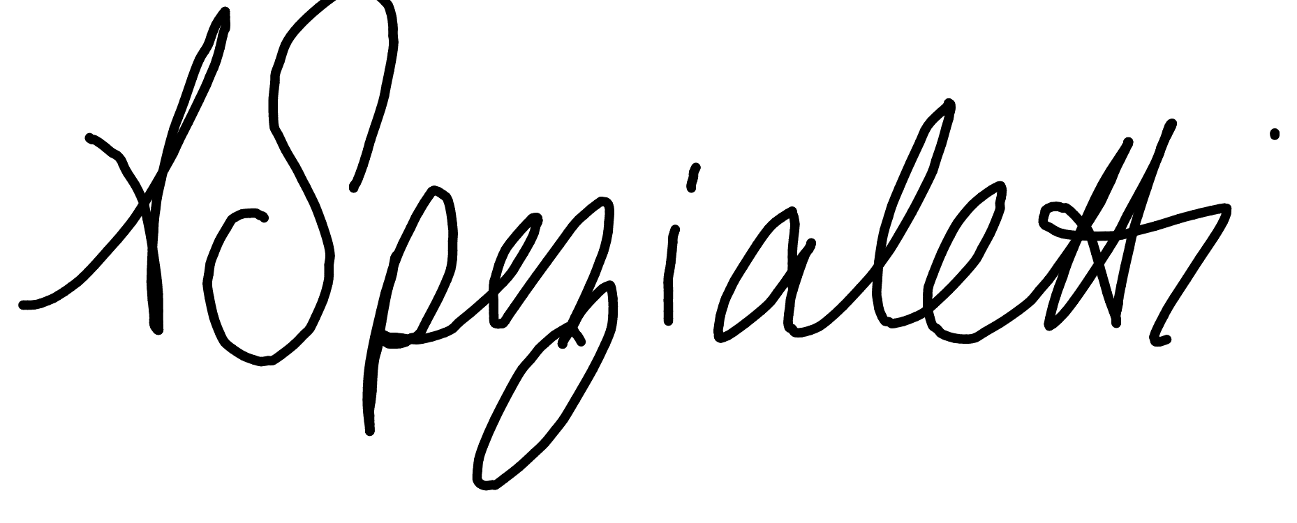
Date: 02/11/2022
Signature:
I, Alicia Spezialetti, do attest that the above information is true and complete.

